I suggest choosing Agile methodology, because :
- Requirments charateristics: ( đặc điểm yêu cầu)
+
+
- Develepment team: ( nhóm phát triển )
+ Quy mô
+ Mức độ hiểu biết ( kinh nghiệm)
- User involvement int the project : ( sự tham gia của người dùng)
+
- Conclusion :
Waterfall khi là một team chuyên nghiệp, và các yêu cầu đã xác định rõ ràng rồi
Có sự Tham gia nhiều thì AGILE

Chỉ chọn WATERFALL khi:
+ Yêu cầu bắt buộc phải rõ ràng rồi, ít thay đổi thôi
+ Có đội support để cùng làm rõ yêu cầu
+ Team phải là một team phát triển chuyên nghiệp, có kinh nghiệm
+ Quy mô dự án: nhỏ, trung bình
+ Có sự tham gia ít
Còn lại: Chọn AGILE
2.
- 4 functional requirements for employee:
+
+
+
+
- 2 non-functional requirements of system:

Function : liên quan đến data
Non-Function : cái gì đạt được khi hệ thống được thực thi
2:
- 4 function requirements for employee:

- 2 non-functional requirements of system:

3: Write 2 user story of employee role:
+ As a [role] … , I want to [action] … , so that [purpose] …
Ex: As a employee , I want to view my schedule of working, so that I can calculate my salary.
As a employee , I want to view my shift by month , by week , by day , so that I can

Question 5:
A
I do not clearly agree with this require, I will choose WATERFALL
method for this situation. Because the requirements are very clearly and
pre-defined. In addtion, our team are a software development
professional in this bussiness, indicated to run into all kids projects and
situations within those projects. So I think waterfall methodology is
suitable for this situation.
=>
I don't entirely align with this stipulation; my inclination is to adopt the WATERFALL approach in this context. The lucidity and predetermined nature of the requirements render it apt for our team, which comprises seasoned professionals in software development. Given our team's proficiency in handling diverse projects and the array of situations within them, I believe the waterfall methodology aligns well with the needs of this specific situation.

Câu 5 B:
I suggest black-box testing for this project. Because, in this project,
the requirements of start-up is clearly, pre-defined, easy to understand.
Secondly, Start-up cares much about the functional requirements. A
professional team helps testing process is easier.
=> I propose employing black-box testing for this project. The startup's requirements are explicitly laid out, well-defined, and easily comprehensible. Additionally, the startup places significant emphasis on functional requirements, and the involvement of a proficient team facilitates a smoother testing process.
- Thích thì thêm đoạn này: I recommend black-box testing for this project due to its well-defined and easily understandable requirements, the startup's emphasis on functional requirements, and the availability of a professional team to facilitate the testing process."
Câu 4 :
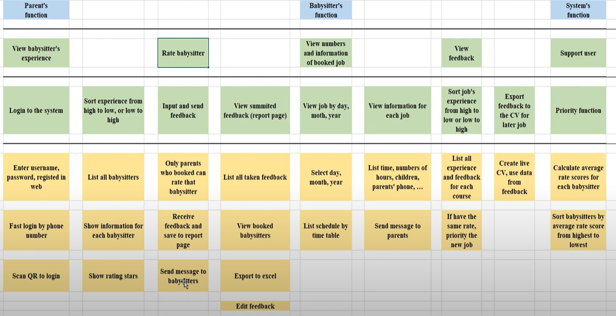
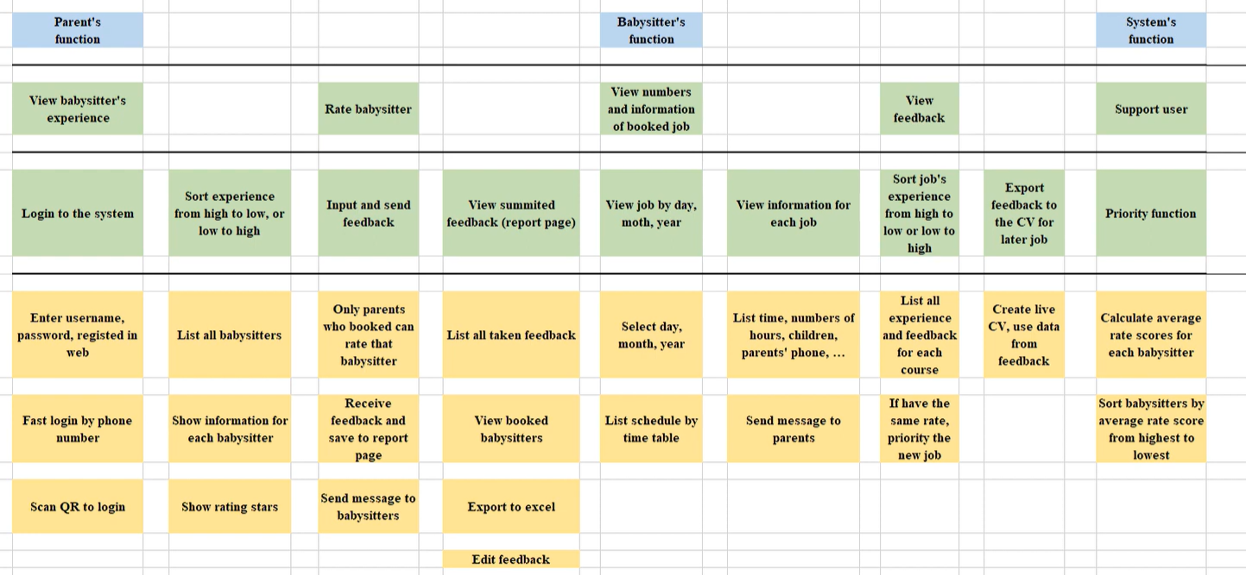
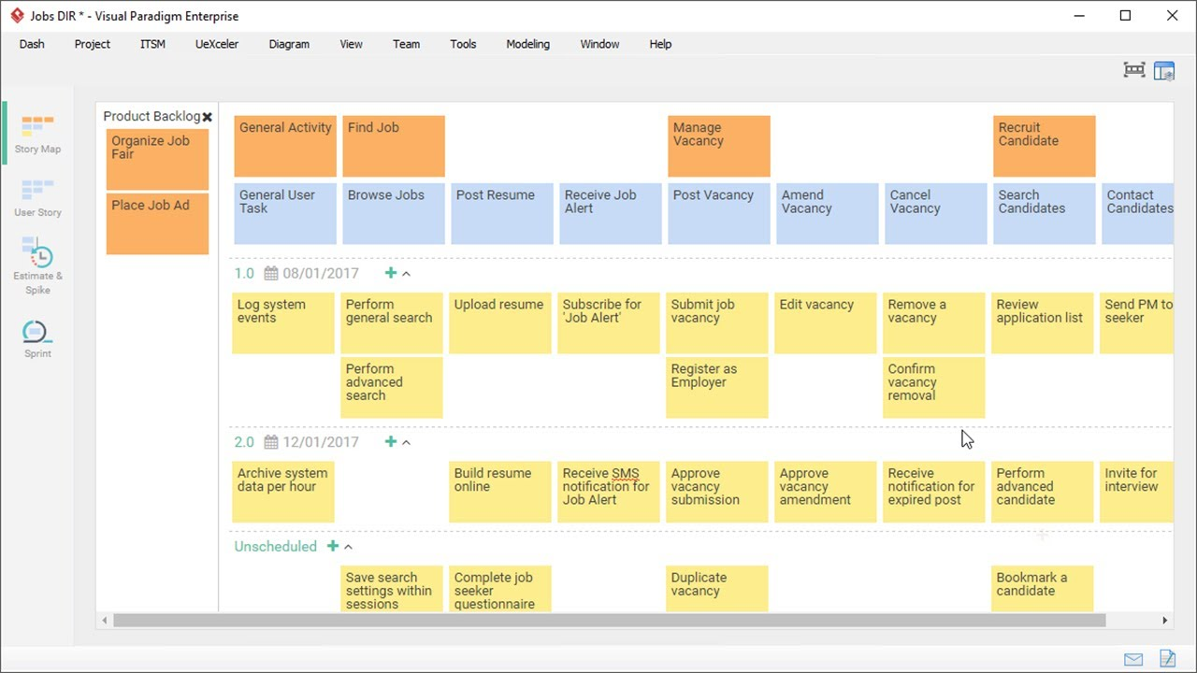
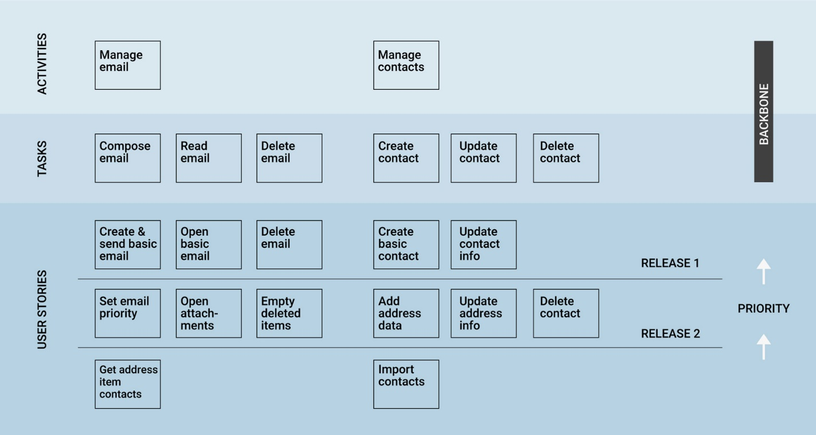
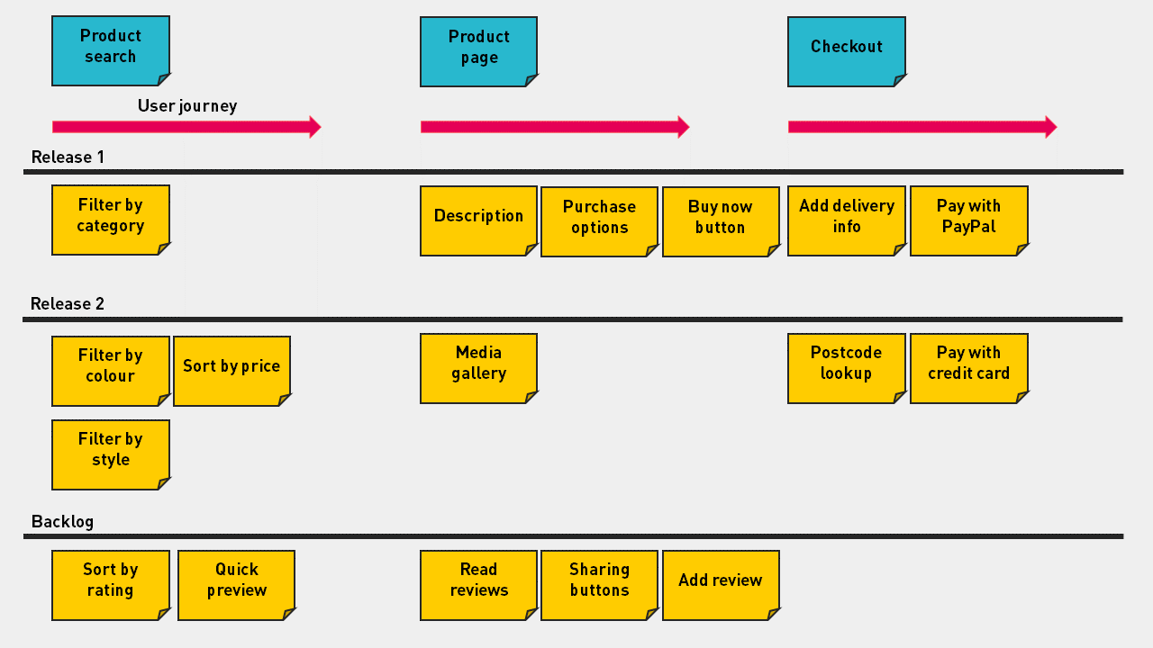
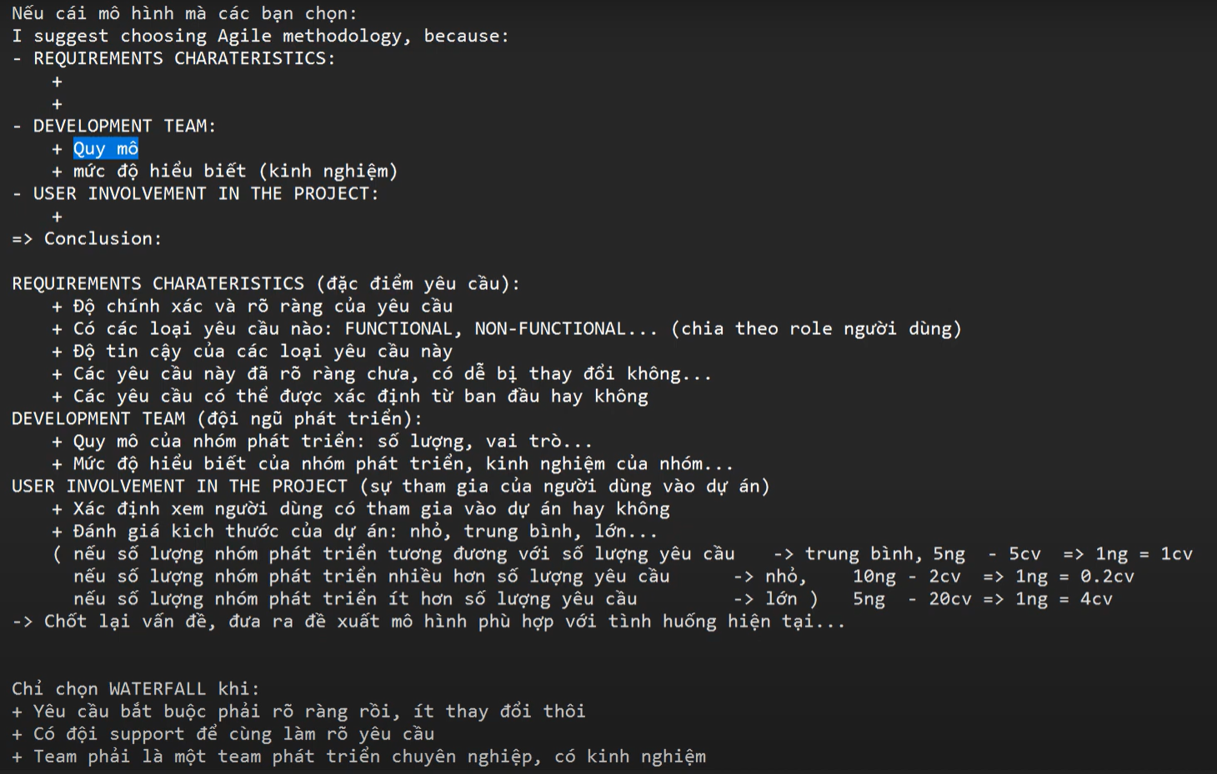

High impact if wrong, High Probability of it being wrong:

Example 1: Financial Trading Algorithm

Explanation: If a high-frequency trading algorithm has a bug (high impact) and there's a high probability of it occurring, it could lead to significant financial losses due to incorrect trades executed at a rapid pace.
Example 2: Medical Diagnosis Software

Explanation: If a medical diagnostic software used in critical healthcare decisions has a flaw (high impact), and there's a high probability of errors, it could result in misdiagnoses, leading to incorrect treatments and potential harm to patients.
High impact if wrong, Low Probability of it being wrong:

Example 1: Air Traffic Control System

Explanation: An error in an air traffic control system (high impact) is rare due to stringent testing and safety measures. However, if it does occur, the consequences could be catastrophic, affecting the safety of numerous flights.
Example 2: Nuclear Power Plant Control System

Explanation: The control system of a nuclear power plant (high impact) is designed with low-probability failures. If a failure does happen, it could lead to severe consequences such as a reactor malfunction or a release of radioactive materials.
Low impact if wrong, High Probability of it being wrong:

Example 1: Spell Checker in Word Processing Software

Explanation: While a spell checker may have a low impact if it occasionally misses a typo, the high probability of such errors occurring could lead to documents with numerous unnoticed spelling mistakes.
Example 2: Automated Parking Assistance in Cars

Explanation: If an automated parking system occasionally misjudges the distance (low impact), but the probability of this happening is high, it may result in minor collisions or scratches during parking.
Low impact if wrong, Low Probability of it being wrong:

Example 1: Weather App Forecasting Light Rain Instead of Sunshine

Explanation: If a weather app occasionally provides an inaccurate forecast (low impact), and the probability of such errors is low, users may experience minor inconveniences but overall trust in the app remains.
Example 2: Fitness Tracker Slightly Overestimating Steps

Explanation: If a fitness tracker occasionally overestimates the number of steps taken (low impact), and the probability is low, it might have a minor impact on a user's daily activity tracking, but the overall functionality remains acceptable.
